

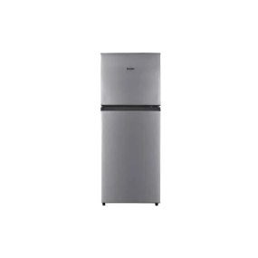

# Haier Refrigerator HRF-186 EBS/EBD

• 125v~260v Operation

• Total Net Capacity (L) ? 156 L

• Faster Cooling & Freezing

• 1HIT Technology

• 10 year compressor 1 year parts warranty